Employee Management System

Submitted in partial fulfillment of the requirements

of the Second Year of Bachelor of Artificial Intelligence & Data Science

By

**Sanidhya Vinod Gaikwad**

**Roll No: 16**

**Suyash Ajay Sonawane**

**Roll No: 60**

**Mayur Surendra Hadap**

**Roll No: 23**

**Prathamesh Satappa Patil**

**Roll No: 44**

# Guide:

**Prof. Sanjay M. Patil**



# DEPARTMENT OF ARTIFICIAL INTELLIGENCE & DATA SCIENCE

**KONKAN GYANPEETH COLLEGE OF ENGINEERING UNIVERSITY OF MUMBAI**

# (2023-2024)

**CERTIFICATE**

This is to certify the project entitled **“****Employee Management System”** is a bonafide work of **“****Sanidhya Vinod Gaikwad Roll No: (16), Suyash Ajay Sonawane Roll No: (60), Mayur Surendra Hadap Roll No: (23), Prathamesh Satappa Patil Roll No: (44)”** submitted to be University of Mumbai in partial fulfillment of the requirement for the award of the **“S.E.”** in **“Artificial Intelligence & Data Science”.**

Prof. Sanjay M. Patil

Guide

(Prof. S. M. Patil) (Dr. V. J. Pillewan)

Head of Department Principal

**KONKAN GYANPEETH COLLEGE OF ENGINEERING, KARJAT.**

(Affiliated to University of Mumbai, Approved by A.I.C.T.E., New Delhi.

Konkan Gyanpeeth Shaikshanik Sankul, Vengaon Road, Dahivali, Karjat, Dist.-Raigad.410201. (M.S.)

**Department of Artificial Intelligence & Data Science**

Project Report Approval

This project report entitled **“Employee Management System”** by “**Sanidhya Vinod Gaikwad Roll No: (16), Suyash Ajay Sonawane Roll No: (60), Mayur Surendra Hadap Roll No: (23), Prathamesh Satappa Patil Roll No: (44)”** is approved for the S.E. of Artificial Intelligence & Data Science.

Examiners

1..........................................

2..........................................

Date.

Place.

**Declaration**

I/We declare that this written submission represents my/our ideas in my/our own words and where others' ideas or words have been included, I/We have adequately cited and referenced the original sources. I/We also declare that I/We have adhered to all principles of academic honesty and integrity and have not misrepresented or fabricated or falsified any idea/data/fact/source in my/our submission. I/We understand that any violation of the above will be cause for disciplinary action by the Institute and can also evoke penal action from the sources which have thus not been properly cited or from whom proper permission has not been taken when needed.

Sanidhya Vinod Gaikwad Roll No: (16) ----------------------------------------

Suyash Ajay Sonawane Roll No: (60) ----------------------------------------

Mayur Surendra Hadap Roll No: (23) ----------------------------------------

Prathamesh Satappa Patil Roll No: (44) ----------------------------------------

Date:

## **Acknowledgement**

We have completed our term paper on the documentation of Software Requirements Specification for an **Employee Management System**. A special thanks to our course instructor Prof. Sanjay M. Patil for his supervision throughout the working time. He helped us a lot by sharing his valuable knowledge with us. We wish to thank all my friends, colleagues, students, brother professionals and the campus staff (Department of Artificial Intelligence & Data Science.), who have help me with the critical review of this project including my Friend’s. Their Debugging skills and grateful appreciated.

# INDEX

|  |  |
| --- | --- |
| **No of Content** | **Page no** |
| Abstract  List of Figures | i ii |
| **1. INTRODUCTION** | 1 |
| 1.1. Introduction | 1 |
| 1.2. Existing System | 2 |
| 1.3. Problem Statement | 3 |
| 1.4. Objectives | 3 |
| 1.5. Scope | 4 |
| **2. REVIEW OF LITERATURE** | 6 |
| **3. REQUIREMENT ANALYSIS** | 8 |
| 3.1. Software Requirement | 8 |
| 3.2. Hardware Requirement | 9 |
| 3.3. System Requirements | 9 |

1. DESIGN AND PLANNING 10
   1. Flow chart /Process Model 10
   2. UML Diagram 11
   3. Data Flow 12
   4. UI Design 13
   5. Gantt Chart 14
2. 15
3. FUTURE ENHANCEMENTS 16

7)CONCLUSION 17

**8)REFERENCES 18**

**ABSTRACT:**

Employee management system is an application based system, having two applications developed, one for employers to manage employee details and another for employees to mark their attendance.

Every organisation whether government or private uses an information system[2.] to store data of their staff. However, in India it is found that many small scale industries use pen and paper to keep a record.

However, there are many advanced technology systems available that can do this work but they all are costly for these low level industries. This paper discusses making a system for solving problems for them at a cheaper cost.

This system will mark attendance of each employee and calculate the salary of them at the end of month.

It also calculates overtime and total working hours of each employee. As in small scale each company has their own holidays preference and variable week off for employees, so all this power is given to the employer to manage holidays and week days of each employee separately.

It saves lots of time and has no error in pay calculation hence preventing clashes between HR Team and employees. So that both employer and employee can focus on their work to develop their company.

|  |  |
| --- | --- |
| **LIST OF FIGURES:** | **PAGE NO:** |
| 1) Flow Chart | 8 |
| 2) UML diagram | 9 |
| 3) Data Flow | 9 |
| 4) Gantt Chart | 12 |

# 

# 

# 

# INTRODUCTION:

Employee information system is easy to use application which is created to manage the employee data. It is created to record the details of the employees. This reduces the dependency on the manual system which could create errors. This system can easily help in tracking employee records. There is a search feature which allows getting records of a specific employee. There is an administrator which can add, edit, delete and save records in a database. There are two views for this application first is the administrator and the second is employee view. The employee view enables employees to view their details.

# Existing System:

In the present Employee Management System of data management, some person maintains the data manually, which required a high amount of time as there are so many people work in the organization.

The organization keeps the record of all the employees in the paper which is not a secure way of maintaining the data. As there is a high amount of register in which information is stored consume a lot of space in the organization while retrieving any information from that many files consume huge time and it is not an easy process.

# Problem Statement:

The problem statement for the Employee management system is as follows:

The employee data or information is very hard to manage by in organization so employee management system is used to manage data or information of employee by an organization and to control data from there ideas.

Objectives:

Specific goals are:

# This project aims to simplify the task of maintaining records of the employees of Company.

# To develop an well designed database to store employee information.

# Provides full functional report to management of company.

# The objective of this project is to provide is to provide a comprehensive approach towards the management of employee information

# Scope:

# This project aims to simplify the task of maintaining records of the employees of Company. This project aims to simplify the task of maintaining records of the employees of Company Search Both employees & the administrator can login to this system & work but with some restrictions. Thus, provides high accessing security.

# We can add new users for both employees & the admin and can also delete the existing logins in case needed.

# Help in maintaining the computerised employee details.

# Calculate the salary.

# Easy attendance marking .

# Computerised Events and Requests Management .

# Create new users to the system accordingly.

# To develop an well designed database to store employee information

# REVIEW OF LITERATURE:

Literature review consists of various sections that tells us about application and benefits of using this the organization still uses the This project eliminates or reduces as much as possible the difficulties of the existing system and avoids errorswhile entering data.ordinary classical methods which are merely based on pen-paper to Large quantities of registers are to be maintained for this purpose which results in downright waste of time in generating reports or searching for employee’s records and loss of data if any file is lostrecord the data of their employeessystem.Management is not only about managing resources and controlling expenses. Although these are basic functions of management, there’s more to management than just managing resources and controlling expenses. Another extremely important function of management is the ability to manage employees .Employee information system is easy to use application which is created to manage the employee data. It is created to record the details of the employees. This reduces the dependency on the manual system which could create errors. This system can easily help in tracking employee records. There is a search feature which allows getting records of a specific employee. There is an administrator which can add, edit, delete and save records in a database. There are two views for this application first is the administrator and the second is employee view. The employee view enables employees to view their details.

# REQUIREMENT ANALYSIS:

## **Software Requirement:**

Functional requirements define what the employee should do. Some of the functional requirements for a employee management system include:

* The employee should add their name..
* The user can add their phone,email,address
* The user can edit their data.
* The user can apply for leave.

Non-functional requirements define how the employee should perform. Some of the non-functional requirements for a employee management system include:

* The employee management system should be easy to handle
* The employees data should be stored in a database properly
* The employees data should be easy to update, delete and display in the mangement system

## **Hardware Requirements:**

Here are some general hardware requirements for a Employee Management System:

CPU: Dual-core processor

RAM: 2 GB RAM

Storage: 5 GB free disk space

Operating system: Windows 7, macOS 10.9, or Linux

## **System Requirements:**

# In the development system we will refer to the develop phase and will follow the certain requirements in order to make work more efficiently.

**DESIGN AND PLANNING:**

**Flow chart:**

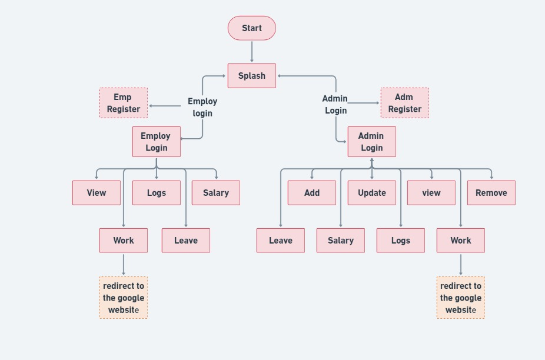

### **UML Diagram:**

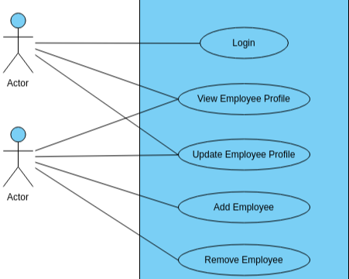

**Data flow:**

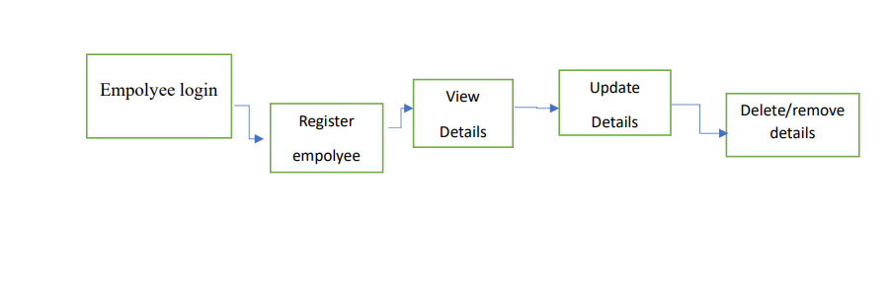

### **UI Design:**

**Gantt Chart:**

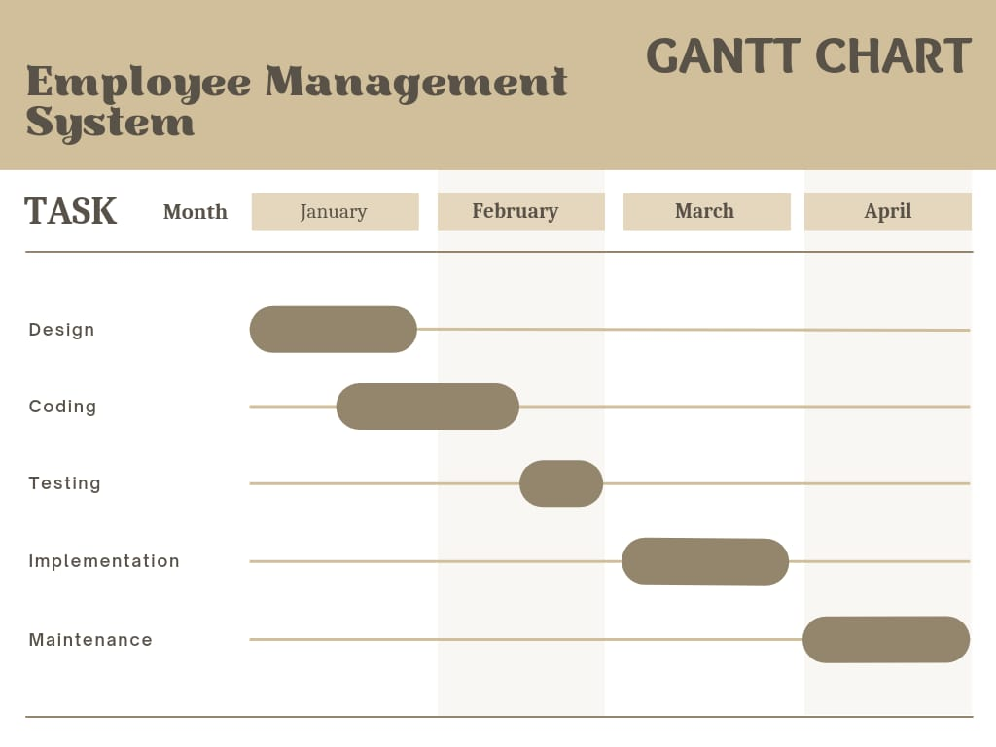

**FUTURE ENHANCEMENT**

Here are a few ideas for future enhancements to Employee management system

* This project can be modified in future according to the need of the empolyees, administrator and users
* This project can be used not only as the information system but as the management system also only by including some more management features and modifications.
* This includes a track on employee in an orgination and collect there data and register employee in system
* Future enhancements for employee management systems involve improving and expanding upon existing tools and processes to make them more efficient, productive, and employee-friendly

# CONCLUSION:

It was a great experience to design and implement the Employee Management System by using statements java Programming Language and to work on its documentation. While working on this project, We have learned many things especially how to apply the concepts of java programming . This assignment helped me to get the better understanding to develop and derive new class

It also helped me in getting in the better understanding of basic programming concepts of java language such as inheritance, interface, arrays etc.